Predicting Incident Management Service Level Agreement (SLA) Failures

Capstone Task 3 – Presentation

Carolyn M. Hennings

Western Governors University

[chenn15@wgu.edu](mailto:chenn15@wgu.edu)

Agenda

Introduction

Problem Statement

Hypotheses

Data Analysis Process

Collect

Extract and Prepare

Analyze

Findings

Limitations of Techniques and Tools

Proposed Actions

Benefits

Summary

References

# Introduction

Carolyn M. Hennings

ITIL® Expert

Project Management Professional®

Professional Experience

IT Strategy

Business Analysis

Performance Improvement

IT Service Management

# Problem Statement

Incident Management

Minimize the duration of interruptions in normal service operations while also minimizing the impact of those interruptions (Hanna, 2011)

Service Level Agreements

Describe services and establish service level targets as negotiated and agreed upon between the service provider and the customer (Hanna, 2011)

SLA Compliance

Resolve incidents within agreed timeframes

What factors predict Incident Management SLA compliance?

Can a logistic regression model predict incidents likely to breach an SLA?

# Hypotheses

Non-zero coefficients in a logistic model indicate factors contributing to SLA compliance

Formal Definition

H0: Data contains no significant indicators about the final SLA status of an incident (the coefficients of a logistic regression model are zero, )

H1: Data contains significant indicators about the final SLA status of an incident (the coefficients of a logistic regression model are not zero, $β_{i}≠0$)

# Data Analysis Process

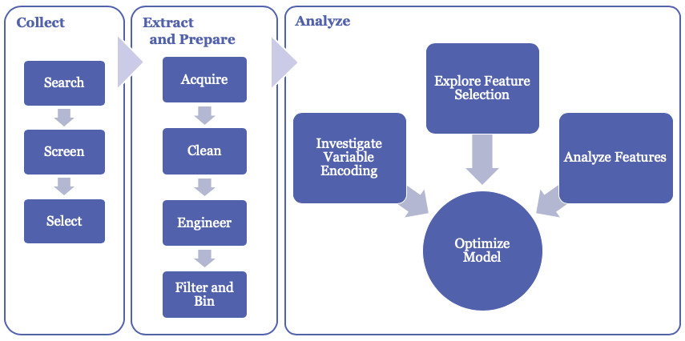

## Collect

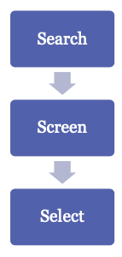Internet search of publicly available data sets

Considered

* UCI Machine Learning Repository Incident management process enriched event log Data Set (Amaral et al., 2019)

Selected

* *2014 Business Processing Intelligence Challenge (BPIC) Incident Records file (Van Dongen, 2014)*

## Extract and Prepare

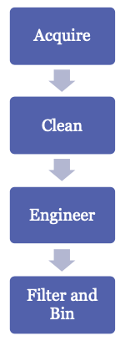

Engineer the Target Variable (SLAFail)

|  |  |
| --- | --- |
| Priority | Time Between Opened and Resolved |
| 1 Very High | Greater than 240 minutes (4 hours) |
| 2 High | Greater than 480 (8 hours) |
| 3 Medium | Greater than 1440 (1 day) |
| 4 Low | Greater than 2880 (2 days) |
| 5 Very Low | Greater than 5760 (4 days) |

## Analyze

Evaluation Criteria

Classification Accuracy

|  |  |  |  |
| --- | --- | --- | --- |
| Accuracy: 75% | | Predicted | |
| 0 | 1 |
| Actual | 0 | TN: 6597 | FP: 848 |
| 1 | FN: 1827 | TP: 1291 |

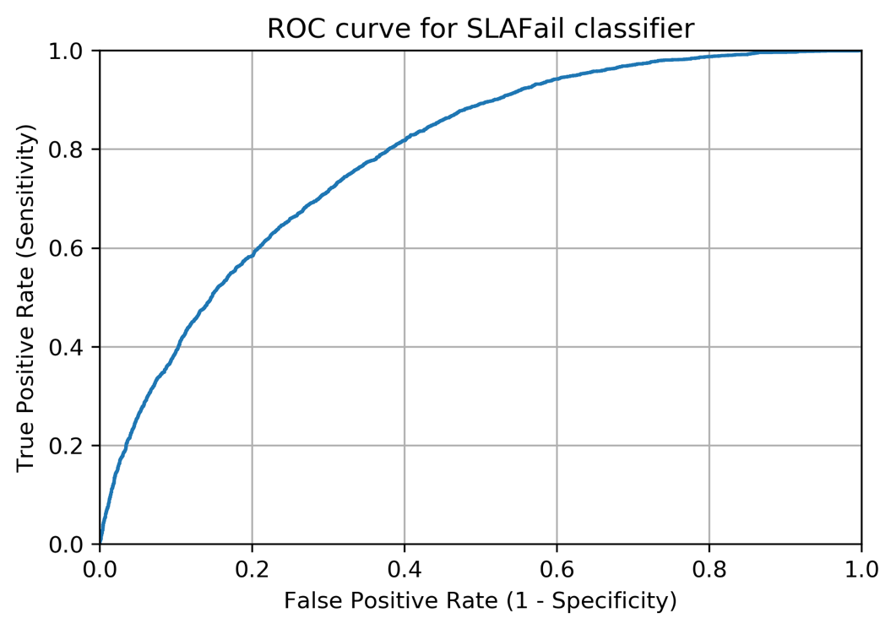Area Under the Curve (AUC)

# Findings

|  |  |  |  |
| --- | --- | --- | --- |
| Variable | Coefficient | F score | P-value |
| Service_Component_WBS_aff | 0.1040 | 141.5840 | 0.0000 |
| Urgency | 0.1881 | 6104.4400 | 0.0000 |
| KM_number | 1.1217 | 177.7560 | 0.0000 |
| Count_Related_Interactions | 1.1726 | 679.7630 | 0.0000 |
| Count_Related_Incidents | 1.2459 | 902.1090 | 0.0000 |
| Count_Related_Changes | 0.0388 | 62.0758 | 0.0000 |
| Open_Time_HourOfDay | 0.1824 | 5.6072 | 0.0179 |
| Open_Time_DayOfWeek | -0.0358 | 0.3519 | 0.5530 |

P-values < 0.05 indicate statistically significant coefficients

Accept the Null Hypothesis

* The data contains significant indicators of final SLA status

However:

* Best model achieved 78% classification accuracy
* Null Accuracy resides at 70%

# Limitations of Techniques and Tools

|  |  |  |
| --- | --- | --- |
|  | Benefits | Limitations |
| Feature Selection | Identification of most discriminatory factors | Required manipulation of data types through encoding of categorical variables and standardization of numeric variables |
| Factor Analysis |
| Logistic Regression Model | Appropriate and industry accepted technique for classifying binary response variables |
| Python | Cost effective programming language with extensive data analytics capabilities | Computing resource requirements |

# Proposed Actions

|  |  |
| --- | --- |
| Observation | Recommendation |
| Configuration Items and Knowledge Articles appeared as strong indicators of SLA breaches | Investigate specific Configuration Items and Knowledge Articles that significantly contribute to SLA breaches |
| Limited data about categories of Knowledge Articles and impacted users | Collect additional data for inclusion in the model |
| Logistic Regression provided only slightly better results | Consider other classifier techniques such as decision trees, support vector machines (SVM), or *k* nearest neighbors |

# Benefits

|  |  |
| --- | --- |
| Role | Benefit |
| Service Desk Agents | * Swift identification of incidents requiring prioritized attention |
| Incident Managers | * Ability to make resource allocation decisions * Reduction of incident duration |
| Customers | * Increased availability of services |

Increased Customer Satisfaction

# Summary

Exploratory Study

Mixed Results:

* Hypothesis accepted
* Marginal value

Contact:

Carolyn M. Hennings

chenn15@wgu.edu

# References

Amaral, C., Fantinato, M., Reijers, H., & Peres, S. (2019). *Enhancing Completion Time Prediction Through Attribute Selection*. https://doi.org/10.1007/978-3-030-15154-6_1

Hanna, A. (2011). *ITIL(r) glossary and abbreviations*. AXELOS Limited. https://www.axelos.com/corporate/media/files/glossaries/itil_2011_glossary_gb-v1-0.pdf

Higgins, S. (2016, April 26). *How predictive analytics have turned Incident Management on its head -*. http://www.theitsmreview.com/2016/04/predictive-analytics-turned-incident-management-head/

Van Dongen, B. F. (Boudewijn). (2014). *BPI Challenge 2014: Incident details*. Rabobank Nederland. https://doi.org/10.4121/UUID:3CFA2260-F5C5-44BE-AFE1-B70D35288D6D